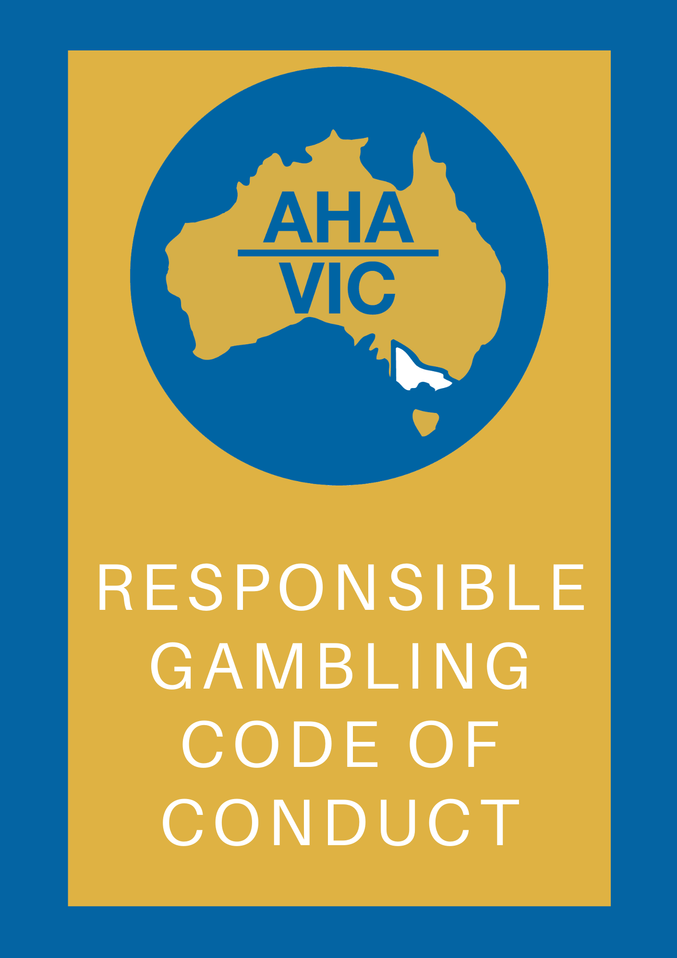

AUSTRAL HOTEL

Responsible Gambling Code of Conduct

Responsible Gambling Message
This venue will take all reasonable steps to prevent and minimise harm from the operation of gaming machines in this venue, including by monitoring the welfare of customers, discouraging intensive and prolonged gaming machine play and intervening when a customer is displaying behaviour that is consistent with gambling harm.
This venue’s code will be made available on our website (where a website exists) and in written form to customers upon request. A sign advising customers of this will be displayed in the gaming area.
The code will also be available in community languages on our website (where a website exists). Languages may include:
  - Arabic
  - Cantonese
  - Greek
  - Hindi
  - Italian
  - Mandarin
  - Punjabi
  - Vietnamese

Interaction and Communication with Customer
  - This venue will ensure that communications with customers does not:
    - Induce a customer to enter or remain in the gaming machine area
    - Induce gaming machine play (with the exception of communication that forms part of a loyalty program), or
    - Reinforce or encourage fallacies or misconceptions about gaming machines, including but not limited to:
      - Telling a customer that they can make money playing a gaming machine
      - Telling a customer that a gaming machine or gaming machine jackpot has or has not paid, or that it is due to pay winnings
      - Discussing luck or superstitions
      - Telling a customer that a ‘near miss’ means the gaming machine is about to
pay winnings

R e s p o n s i b l e G a m b l i n g C o d e o f C o n d u c t Page 1

      - Suggesting or encouraging the belief that a spin on a gaming machine is not independent of another spin on that gaming machine
      - Suggesting or encouraging the belief that there are strategies that a customer can use to win when playing a gaming machine (for example, increasing or decreasing the amount bet per line or number of lines on which a bet is made), or
      - Telling a customer that they deserve to win.
  - This venue will take reasonable steps to ensure that communications with customer discourage intensive and prolonged gaming machine play.
  - With the exception of EFTPOS signage, this venue will not induce a customer to:
    - Withdraw money, or withdraw more money, from a cash facility, or
    - Leave this venue to obtain money, or obtain more money, to enable that customer to play, or to continue to play, a gaming machine.
  - This venue may however direct a customer to a cash facility when requested to do so by the customer.

Interaction with Customers – Signs of Distress
  - This venue will take all reasonable steps to ensure the gaming machine area and entrances to the gaming machine area are monitored at all times gaming machines are available for play.
  - This venue will take all reasonable steps to ensure that customers in the gaming machine area are regularly observed to monitor behaviour that is consistent with gambling harm.
  - This venue will not encourage or induce a customer to engage in intensive or prolonged gaming machine play.
  - Staff at this venue will ask a customer to take a break away from the gaming machine area where an interaction has occurred and that interaction has determined that the customer is angry while gaming or has requested assistance as a consequence of their gaming.
  - Staff at this venue will interact with a customer who has been observed to have been playing gaming machines for a prolonged period without a break and ask that customer to take a break away from the gaming machine area.
  - Staff at this venue will interact with a customer who:
    - Has been asked to take a break and refuses to take a break away from the gaming machine area
    - Plays multiple gaming machines simultaneously, or
    - Reserves a gaming machine in order to play another gaming machine.

R e s p o n s i b l e G a m b l i n g C o d e o f C o n d u c t Page 2

Gaming Venue Staff
  - Staff at this venue are not permitted to play a gaming machine on a rostered day of work at this venue.
  - This venue provides information to staff so that they are aware of their increased risk of harm from gambling.

Interaction with Problem Gambling Support Services
This venue will ensure that staff who have day-to-day management of the operation of this venue and responsible gambling officers meet with this venue’s nominated venue support worker at least once every six months.

The Gambling Environment
  - This venue will not encourage a customer to play multiple gaming machines simultaneously.
  - This venue will take all reasonable steps to discourage a customer from reserving a gaming machine in order to play another gaming machine in the gaming machine area.
  - During the opening hours of food and beverage facilities outside the gaming machine floor, this venue will ensure that a customer can order and be served food and beverage without having to enter the gaming machine area.
  - This venue may offer a customer seated at or playing a gaming machine food or beverage provided it is offered as part of an interaction with that customer.

Responsible Gambling Officer
  - Responsible Gambling Officers have been appointed at this venue.
  - A Responsible Gambling Officer will be available in the gaming machine area at all times gaming machines are available for gaming.
  - This venue will display prominently in the gaming machine area a notice advising that a Responsible Gambling Officer is available for assistance at all times.
  - This venue’s Responsible Gambling Officer will take all reasonable steps to:
    - Monitor the gaming machine area and ensure compliance with the Act, regulations and this code
    - Ensure that staff record responsible gambling incidents and interventions in the responsible gambling register
    - Observe customers who display behaviour that is consistent with gambling harm and provide assistance as necessary
    - Provide advice to staff about gambling harm and how to respond to signs of gambling harm, and
R e s p o n s i b l e G a m b l i n g C o d e o f C o n d u c t Page 3

    - Respond to customer enquiries and complaints about the supply of gambling in the approved venue.
  - This venue’s Responsible Gambling Officer will complete prescribed responsible service of gambling training, if any.

Responsible Gambling Register
  - This venue maintains a responsible gambling register. The details of all responsible gambling incidents and interventions are recorded in this register, including:
    - Date and time the incident occurred
    - Details of the incident
    - Details of the intervention made in response to the incident
    - Details of the customer’s response to the intervention, if known
    - Date and time the entry was recorded in the responsible gambling register, and
    - The name of the individual, if this is provided voluntarily by that individual.
  - This venue retains the information in the responsible gambling register for not less than six months from the day it was recorded in the responsible gambling register.
  - This venue will provide a copy of the responsible gambling register to the Victorian Commission for Gambling and Liquor Regulation on request.
  - This venue may provide information in the responsible gambling register to a Venue Support Worker for training and development purposes provided that information does not include the name or identifying characteristics of any customer.

R e s p o n s i b l e G a m b l i n g C o d e o f C o n d u c t Page 4

Appendix-Definitions

Definitions
Code administrator refers to Australian Hotels Association (Victoria) who has prepared and administer this code.
Interaction means measured assistance based on a case-by-case assessment by venue staff. The interaction may take the form of:
- Encouraging the customer to consider food or beverage offers available at the venue which would allow a break in play from the gaming machine
- Offering the customer some refreshments (e.g. tea or coffee) in a quieter, more private part of the gaming venue where the customer has the opportunity to request appropriate support information in a confidential manner
- Assisting the customer with travel arrangements in order to depart the venue
- Providing customer with information on gambling support, and
- Explaining how the self-exclusion program works and providing information on how to access the program.
Loyalty program means a ‘loyalty scheme’ as defined in section 1.3 of the Act.
Responsible Gambling Officers describes staff appointed to assist the venue operator to:
- Minimise gambling harm in the venue
- Ensure compliance with all responsible gambling regulatory and code requirements, and
- Respond to staff and customer enquiries about the supply of gambling in the venue.
Responsible Gambling Register describes a log located in the gaming area that venue staff have access to record responsible gambling related interactions with customers.
Venue Support Workers describes staff from the Gambler's Help Venue Support Program. These staff assist venues in fulfilling responsibilities such as:
- Identifying and responding to patrons displaying signs of problem gambling
- Raising awareness among venue staff about, and encouraging referrals to Gambler's Help services, self-exclusion programs and other community support services
- Meeting the requirements of their Responsible Gambling Codes of Conduct
- Creating and maintaining responsible gambling environments
- Ensuring their completion of the required Responsible Service of Gaming (RSG) training.

R e s p o n s i b l e G a m b l i n g C o d e o f C o n d u c t Page 5

Disclaimer
Any legislative changes impacting on this code do not render this code as invalid. Any State or Federal legislation or regulatory arrangements take precedence over the contents of this code.

R e s p o n s i b l e G a m b l i n g C o d e o f C o n d u c t Page 6

